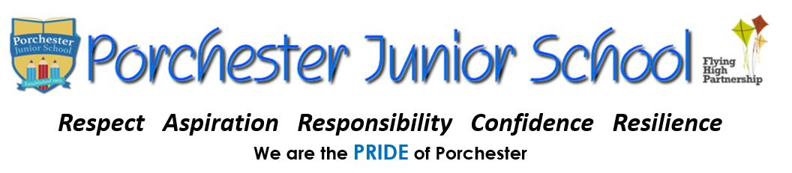
Creative Enquiry Home Learning
This term, we are learning all about WWII. Here is a selection of creative home learning activities that you might enjoy at home. How many can you complete throughout the term…?
Design a Propaganda poster to persuade people to join the Army.  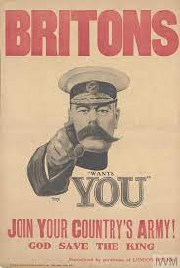 | 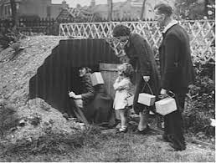  Build a 3D model of an air-raid shelter or Anderson shelter | 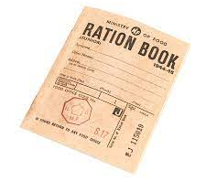  Find a WWII recipe and make it at home.
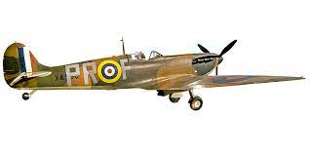  Draw and label an airplane from WWII (e.g. British Spitfire) | Research and make a PowerPoint about Winston Churchill.  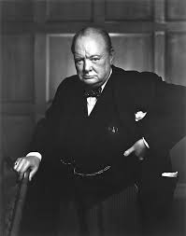 | 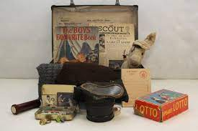  Draw and explain what six things that you would want to take with you if you were evacuated.
Read and review a war-based book. Eg. Goodnight Mr Tom, Once, The Lion and the Unicorn War Horse. (We have all of these in the school library!)  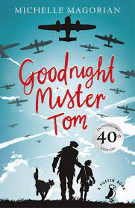 | Create your own piece of Art about The Blitz.  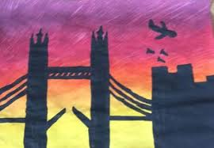 |   Write a war-based story or poem.

