Porchester Junior School
Upper School Curriculum Booklet
Autumn 2026

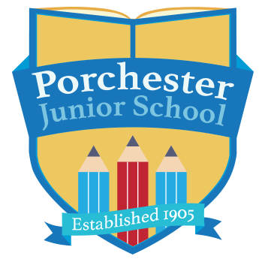



This booklet is aimed at informing you, as parents, of the work that will be covered over the Autumn term 2026.


Dear Porchester families,

Welcome back everyone! We hope you all enjoyed your holidays, and the children are feeling revitalised! It is great to see all the children again so eager and raring to go. Everyone is showing that they are prepared for the challenges of the year but also the fun we will have along the way. We are really looking forward getting back into the swing of our routine and having an exciting term together!

- P.E. – Thursday – please ensure your child is in proper school PE kit on these days.

- Reading – As part of their homework, we do expect the children to read regularly at home. Reading is crucial to all aspects of children’s learning and regular reading at home remains important, even as your children begin to read more independently. Please ensure that your child has their reading diary every day, especially Fridays, as this is when we will be checking their reading at home. Children will receive a house point for every read at home and will be entered into the reading raffle if they read 5 times at home within one week. If you need any support with your child’s reading, please do talk to your class teacher as we want to help support and develop your child’s love of reading.

- Times tables - Times tables remain a key focus in Upper School to ensure all children can fully access the Year 5/6 maths curriculum. It is essential that children are fluent in their times tables to 12x12. All children have been provided with a Times Tables Rock Stars login and we encourage them to use this at home to support their learning and recall.

- Spelling homework –From this year, we will be using the Essential Spelling and Word Knowledge programme to teach spelling in school. This approach differs slightly from our previous method, as it does not rely on weekly word lists and spelling tests. Instead, children will explore spelling patterns and rules within related word families, helping them develop a deeper understanding of how words work. To support their learning, children will complete a weekly online spelling quiz through the Oxford Owl platform. Login details will be sent home by the end of the first full week of term. Quizzes will be set each Monday and should be completed by Friday of the same week. A breaktime homework club will be available for any children who are unable to complete their spelling quiz at home before the Friday deadline.

- Maths homework – Weekly maths homework will concentrate on essential maths skills and will support the children’s learning in school. This is to support the learning in school and prepare children for secondary school. We will give this out on a Friday and collect the following Friday so children will have a week to complete it. Year 6 will be set their Maths homework on the SATs Companion website.

If Spelling and Maths homework is not returned to school by Friday each week, children will be supported to complete this during a break time homework group.

Thank you for your on-going support. We hope you find this information helpful and are looking forward to another exciting term at Porchester!

Mrs Green, Miss Rolley and Mrs Heathcote

Please feel free to contact us at school if there are any comments about this booklet, or if there are ways in which we could improve our school/parent links in the future.

Tel: 0115 9520920
Email: office@porchester.net
Website: https://www.porchester.notts.sch.uk/

English | This term, we will be studying many different genres: narratives and flashback stories, diary entries, biographies and classic poetry.  We will also be using these books and stories in class:  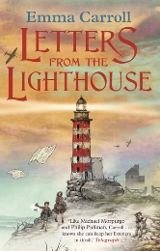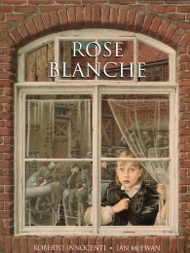
Maths | Year 5  Place value  Addition and subtraction  Multiplication and division  Fractions | Year 6  Place value  Addition and subtraction  Multiplication and division  Fractions  Converting units
Enquiry | Why is it so important to remember the past?
History | WWII  | Science | Light & Forces  
Geography | Locating world countries | Art & DT | Sketching and drawing
Music | Musical ensemble  Music theory with keyboards   | PE | Dance & Gymnastics  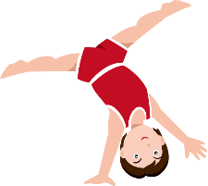
French | Introduction to French    Presenting myself | Computing | E-safety  Using Canva
RE | Autumn 1  Teachings, wisdom & authority  Religions – Buddhism, Humanism | Autumn 2  Beliefs in action in the world  Religions – Judaism
PSHE |   Managing hurtful behaviour and bullying  Keeping safe

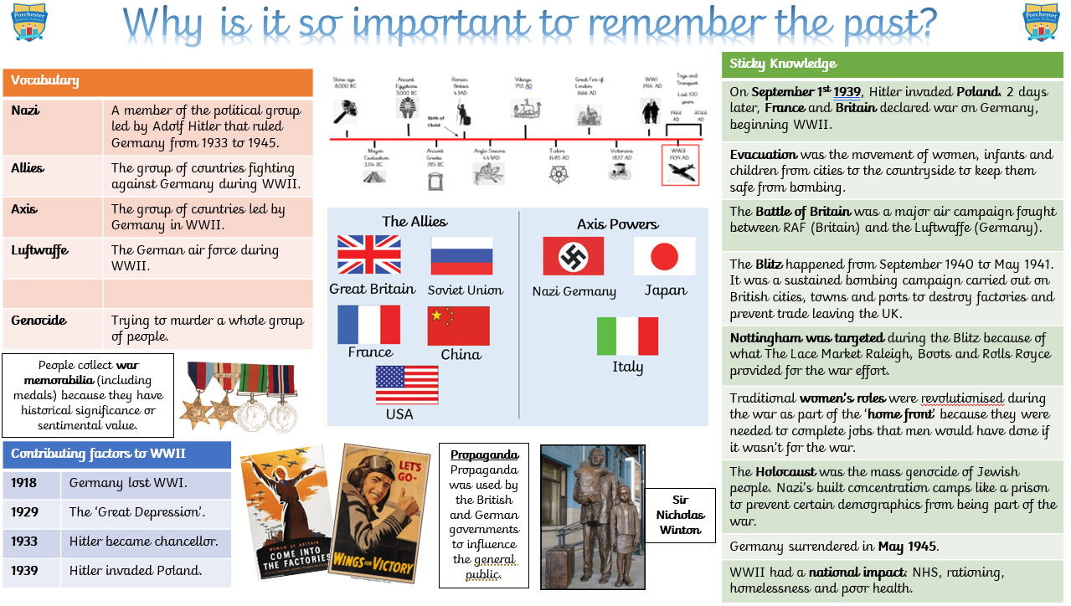


Creative Enquiry Home Learning
This term, we are learning all about WWII. Here is a selection of creative home learning activities that you might enjoy at home. How many can you complete throughout the term…?
Design a Propaganda poster to persuade people to join the Army.  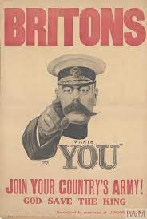 | 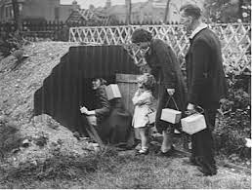  Build a 3D model of an air-raid shelter or Anderson shelter | 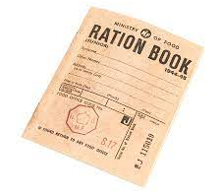  Find a WWII recipe and make it at home.
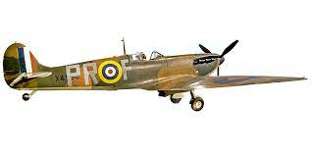  Draw and label an airplane from WWII  (e.g. British Spitfire) | Research and make a PowerPoint about Winston Churchill.  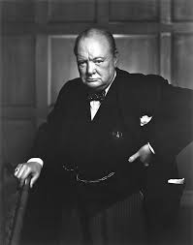 | 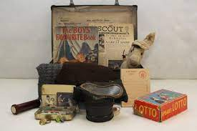  Draw and explain what six things that you would want to take with you if you were evacuated.
Read and review a war-based book. Eg. Goodnight Mr Tom, Once, The Lion and the Unicorn War Horse. (We have all of these in the school library!)  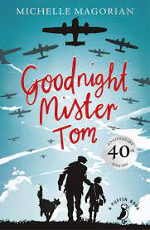 | Create your own piece of Art about The Blitz.   |   Write a war-based story or poem.

