Creative Homework – Autumn 2026
This term, we have made a great start on our enquiry – “What makes a Successful Society?” where the children have been learning all about Ancient Greece. We’d love for you to continue your learning at home and have a go at some of the suggested activities below! Or if you have your own creative idea to enhance your learning about Ancient Greece, we’d love to see what you get up to. Please bring into school or send on dojo to your teacher.

Create a piece of art showing an ancient Greek god of your choice.  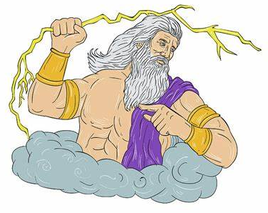 | 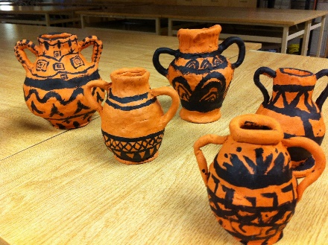  Build a 3D model of a Greek vase. You could use any materials to sculpt your masterpiece! | 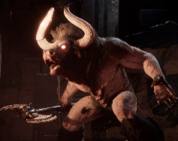  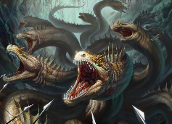  Create a PowerPoint about a chosen mythical creature. You could focus on: the minotaur, hydra or even a centaur.
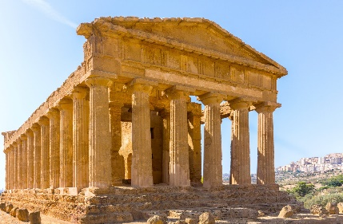  Find out about Greek temples and draw your own temple! | 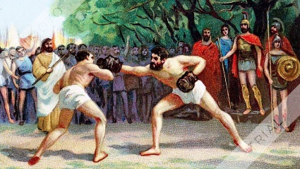  Record a sports commentary for an Olympic sport of your choice. Don’t forget to use your voice to make it interesting! | Retell the story of the Trojan War as if you were one of the soldiers hiding in the wooden horse!  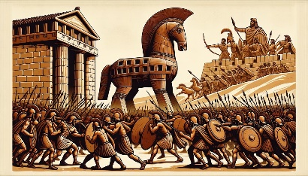
Try and visit your local library and find some books on the Ancient Greeks. Create a colourful poster with all the facts you have learnt! 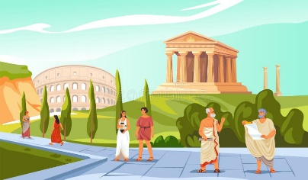 | 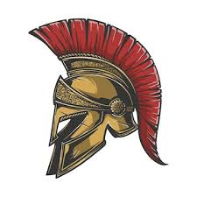  Design and make your own Spartan helmet or shield! | 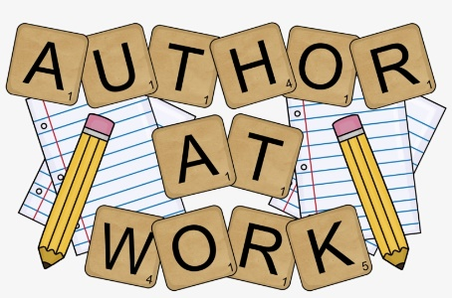  Write a story or poem inspired by your learning about Ancient Greeks.

