Porchester Junior School
Lower School Curriculum Booklet
Autumn 2026

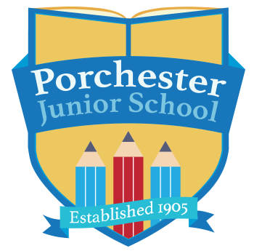



This booklet is aimed at informing you, as parents, of the work that will be covered over the Autumn term 2026.

Dear Porchester families,

Welcome back, everyone!
I hope you all had a lovely summer break and enjoyed lots of special time with family and friends. I am so excited to welcome the children back to school and, as their new class teacher, I am especially looking forward to getting to know them and watching them grow and flourish throughout the year.
I hope the children are feeling refreshed, happy and ready for an exciting Autumn term. I have lots of fun and engaging learning experiences planned, and I can’t wait to share these with the children as we begin our journey together. My aim is to create a happy, welcoming classroom where every child feels valued, confident and excited to learn.
I also love hearing about the wonderful things the children get up to outside of school, so please do share their achievements, special moments and successes with me throughout the year. I am really looking forward to working together, getting to know you all and making lots of happy memories along the way. Here’s to a fantastic year ahead!

We would just like to give you a little information that you might find useful for the term ahead:

- P.E. – Thursdays – please ensure your child is in proper school PE kit on these days.

- Reading – We do expect all children to read regularly at home. Reading is crucial to all aspects of children’s learning and regular reading at home remains important, even as your child begins to read more independently. Please ensure that your child has their reading diary every day, as we will be checking these regularly and using them to record reading in school. Children will receive a house point for every read at home and will be entered into the reading raffle if they read 5 times at home within one week. If you need any support with your child’s reading, please do talk to your class teacher as we want to help support and develop your child’s love of reading.

- Spelling homework –The children will have spelling lessons each week and a test each Friday. They will be given a spelling sheet on a Monday to support them in practising their weekly spellings at home. This homework is expected back in school by Friday. They are also encouraged to play Spelling Shed at home to help them practise their weekly spellings. We will look at the Spelling Shed leader board in school and those working hard will be rewarded with house points. Weekly spelling tests will take place on a Friday.

- Times tables – Times tables are a key focus for all children in Lower School, particularly for our Year 4 pupils, who will sit the Multiplication Tables Check (MTC) in June 2027. This assessment tests children's recall of all multiplication facts up to 12 × 12, making regular practice and fluency essential. Strong times table knowledge also underpins many areas of mathematics as children progress through Upper School. Children in Year 3 will focus on learning and securing their 3, 4 and 8 times tables, while Year 4 pupils will learn their 6, 7, 9, 11 and 12 times tables and continue practising all multiplication facts in a mixed format. Times tables are great to practise together at home. All children have been provided with a Times Tables Rock Stars login, and we encourage them to use this regularly to support their learning and develop quick, accurate recall.

- Maths homework – Weekly maths homework will concentrate on essential maths skills and will consolidate the children’s learning in school. We will give this out on a Friday and collect the following Friday so children will have a week to complete it.

If Spelling and Maths homework are not completed by Friday each week, children will be supported to complete this during a break time homework group.

We hope you find this information helpful and are looking forward to another exciting year at Porchester!

Mrs Judd
Lower School Team

Please feel free to contact us at school if there are any comments about this booklet, or if there are ways in which we could improve our school/parent links in the future.

English | This term, we will be studying many different genres: narratives, character descriptions, letters, persuasive adverts and even a type of poem called a clerihew!  We will also be using some of these books and stories in class:
Maths | Year 3  Place value  Addition and subtraction  Multiplication and division A | Year 4  Place value  Addition and subtraction  Area  Multiplication and division A
Enquiry | What makes a successful society?
History | Ancient Greece  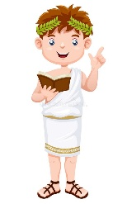 | Science | Animals, including humans  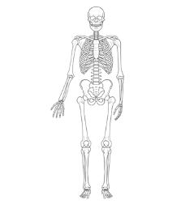
Geography | European countries | Art & DT | Art – Drawing  DT - cooking
Music | Musical ensemble  Music theory with keyboards  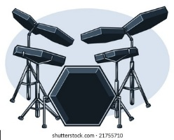 | PE | Dodgeball  Dance  
French | I am learning French   | Computing | Appropriate content & ratings  Computing systems  Online safety  Micro:bit
RE | What can I learn from Hindu families' faith practices, and how do Hindu festivals teach us about values and life?
PSHE |   Families and Close Positive Relationships  Safe Relationships



