Porchester Junior School
Lower School Curriculum Booklet
Autumn 2026

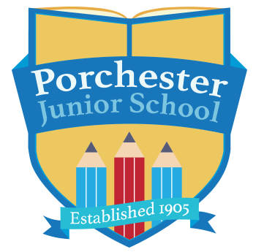



This booklet is aimed at informing you, as parents, of the work that will be covered over the Autumn term 2026.

Dear Porchester families,

Welcome back, everyone!
I hope you have all had a wonderful summer break and enjoyed some well-deserved time with family and friends. It has been lovely to welcome the children back to school, and I hope they are feeling refreshed, settled and ready for an exciting new term! We have a fantastic Autumn term ahead, filled with lots of exciting learning, new experiences and opportunities to grow. I am really looking forward to seeing the children develop their confidence, resilience and independence as we learn and have fun together. I also love hearing about and celebrating the children’s achievements both in and out of school, so please do continue to share these with me throughout the term. Here’s to a fantastic Autumn term!

We would just like to give you a little information that you might find useful for the term ahead:

- P.E. – Thursdays – please ensure your child is in proper school PE kit on these days.

- Reading – We do expect all children to read regularly at home. Reading is crucial to all aspects of children’s learning and regular reading at home remains important, even as your child begins to read more independently. Please ensure that your child has their reading diary every day, as we will be checking these regularly and using them to record reading in school. Children will receive a house point for every read at home and will be entered into the reading raffle if they read 5 times at home within one week. If you need any support with your child’s reading, please do talk to your class teacher as we want to help support and develop your child’s love of reading.

- Spelling Homework – From this year, we will be using the Essential Spelling and Word Knowledge programme to teach spelling in school. This approach differs slightly from our previous method, as it does not rely on weekly word lists and spelling tests. Instead, children will explore spelling patterns and rules within related word families, helping them develop a deeper understanding of how words work. To support their learning, children will complete a weekly online spelling quiz through the Oxford Owl platform. Login details will be sent home by the end of the first full week of term. Quizzes will be set each Monday and should be completed by Friday of the same week. A breaktime homework club will be available for any children who are unable to complete their spelling quiz at home before the Friday deadline.

- Times tables – Times tables are a key focus for all children in Lower School, particularly for our Year 4 pupils, who will sit the Multiplication Tables Check (MTC) in June 2027. This assessment tests children's recall of all multiplication facts up to 12 × 12, making regular practice and fluency essential. Strong times table knowledge also underpins many areas of mathematics as children progress through Upper School. Children in Year 3 will focus on learning and securing their 3, 4 and 8 times tables, while Year 4 pupils will learn their 6, 7, 9, 11 and 12 times tables and continue practising all multiplication facts in a mixed format. Times tables are great to practise together at home. All children have been provided with a Times Tables Rock Stars login, and we encourage them to use this regularly to support their learning and develop quick, accurate recall.

- Maths homework – Weekly maths homework will concentrate on essential maths skills and will consolidate the children’s learning in school. We will give this out on a Friday and collect the following Friday so children will have a week to complete it.

If Spelling and Maths homework are not completed by Friday each week, children will be supported to complete this during a break time homework group.

I hope you find this information helpful and are looking forward to an exciting year at Porchester!

Miss McMath
Lower School Team
Please feel free to contact us at school if there are any comments about this booklet, or if there are ways in which we could improve our school/parent links in the future.

English | This term, we will be studying many different genres: narratives, character descriptions, letters, persuasive adverts and even a type of poem called a clerihew!  We will also be using some of these books and stories in class:  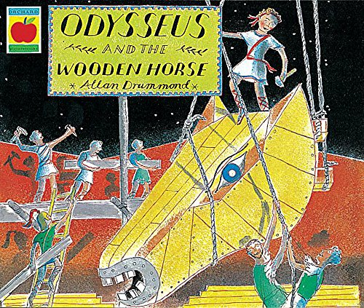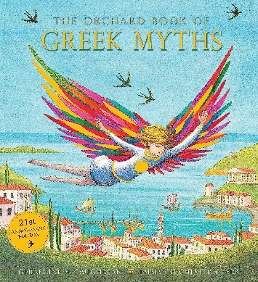
Maths | Year 3  Place value  Addition and subtraction  Multiplication and division A | Year 4  Place value  Addition and subtraction  Area  Multiplication and division A
Enquiry | What makes a successful society?
History | Ancient Greece  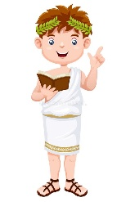 | Science | Animals, including humans  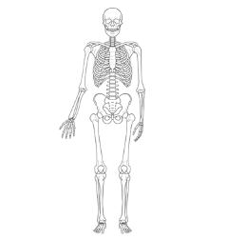
Geography | European countries | Art & DT | Art – Drawing  DT - Cooking
Music | Musical ensemble  Music theory with keyboards  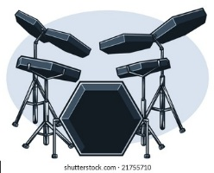 | PE | Dodgeball  Dance  
French | I am learning French   | Computing | Appropriate content & ratings  Computing systems  Online safety  Micro:bit
RE | What can I learn from Hindu families' faith practices, and how do Hindu festivals teach us about values and life?
PSHE |   Families and Close Positive Relationships  Safe Relationships



