Porchester Junior School
Lower School Curriculum Booklet
Autumn 2024





This booklet is aimed at informing you, as parents, of the work that will be covered over the Autumn 2024.

English | This term, we will be studying many different genres: narratives, character descriptions, letters, persuasive adverts and even a type of poem called a clerihew!  We will also be using some of these books and stories in class:    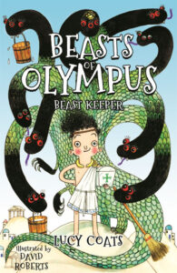  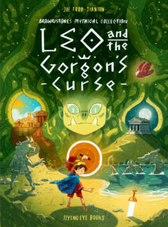  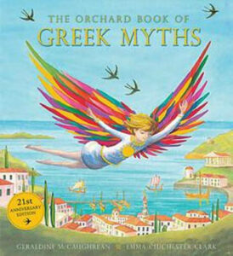
Maths | Year 3  Place value  Addition and Subtraction  Multiplication and Division | Year 4  Place value  Addition and subtraction  Area  Multiplication
Enquiry | What makes a successful society?      
History | Ancient Greece | Science | Animals (including humans) - Nutrition, skeletons and muscles
Geography | Locating countries and cities in Europe.  Comparing the UK and Greece | Art & DT | Sketching  Food technology
Music | Autumn 1  Electric Drums | Autumn 2  Class jamming
Spanish | The phonetics of Spanish  Spanish commands  Musical instruments | Computing | E-safety  Using search engines  Creating programs and reasoning to solve programs
PE | Autumn 1  Dodgeball | Autumn 2  Dance
RE | Spring 1  How do Hindu families practise their faith? What are the deeper meanings behind some Hindu festivals? | PSHE | Families and close positive relationships  Safe relationships (including online)

Dear Porchester families,

Welcome back Year 4 families and welcome to Porchester Year 3 families!

We hope everyone had a lovely summer break and the children are feeling revitalised and ready for a new school year! It is great to see all the children again so eager and raring to go. Everyone is showing that they are prepared for the challenges of the year but also the fun we will have along the way. They have settled in beautifully and we are very exciting for this term.

We would just like to give you a little information that you might find useful over the next few weeks:

- P.E. – Thursday mornings – please ensure your child is in proper school PE kit on these days.

- Reading – We do expect all children to read regularly at home. Reading is crucial to all aspects of children’s learning and regular reading at home remains important, even as your child begins to read more independently. Please ensure that your child has their reading diary every day, as we will be checking these regularly and using them to record reading in school. Children will receive a house point for every read at home and will be entered into the reading raffle if they read 5 times at home within one week. If you need any support with your child’s reading, please do talk to your class teacher as we want to help support and develop your child’s love of reading.

- Times tables –These are a big focus for all children in Lower School, especially for our Year 4 children who will be sitting a Multiplication Check in June 2025. This assessment will test them on all 12 times tables so it is important that we prepare the children for this. Times table knowledge is also vital when supporting the children when they get to Upper School. Year 3 children should already know their 10, 5 and 2 times tables from Year 2, and this year will focus on their 3s, 4s and 8s. Year 4s should hopefully feel confidence in their 10s, 5s, 2s, 3s, 4s, and 8s. This year they will learn their 7s, 9s, 11s and 12s, and will practice all of them mixed up together! Times tables are great to practice together at home and all children have been provided with a Times Tables Rock Stars login and we encourage them to use this at home to support their learning and recall.

- Spelling homework –The children will have spelling lessons each week and a test each Friday. They will be given a spelling sheet on a Monday to support them in practising their weekly spellings at home. This homework is expected back in school by Friday. They are also encouraged to play Spelling Shed at home to help them practice their weekly spellings. We will look at the Spelling Shed leader board in school and those working hard will be rewarded with house points.

- Maths homework – Weekly maths homework will concentrate on essential maths skills and will support the children’s learning in school. This is to support the learning in school and prepare children for secondary school. We will give this out on a Friday and collect the following Friday so children will have a week to complete it.

Thank you for all your support so far this term We hope you find this information helpful and are looking forward to an exciting term at Porchester!

Mrs McDonald, Miss McMath and Miss Wood

Tel: 0115 9520920
Email: office@porchester.net
Website: https://www.porchester.notts.sch.uk/
Twitter: @Porchester

